## What is NumPy?

NumPy is a Python library used for working with arrays.

It also has functions for working in domain of linear algebra, fourier transform, and matrices.

NumPy was created in 2005 by Travis Oliphant. It is an open source project and you can use it freely.

NumPy stands for Numerical Python.

## Why Use NumPy?

In Python we have lists that serve the purpose of arrays, but they are slow to process.

NumPy aims to provide an array object that is up to 50x faster than traditional Python lists.

The array object in NumPy is called ndarray, it provides a lot of supporting functions that make working with ndarray very easy.

Arrays are very frequently used in data science, where speed and resources are very important.

## Joining NumPy Arrays

Joining means putting contents of two or more arrays in a single array.

In SQL we join tables based on a key, whereas in NumPy we join arrays by axes.

We pass a sequence of arrays that we want to join to the concatenate() function, along with the axis. If axis is not explicitly passed, it is taken as 0.

### Example

Join two arrays

import numpy as np  
arr1 = np.array([1, 2, 3])  
arr2 = np.array([4, 5, 6])  
arr = np.concatenate((arr1, arr2))  
print(arr)

## Joining Arrays Using Stack Functions

Stacking is same as concatenation, the only difference is that stacking is done along a new axis.

We can concatenate two 1-D arrays along the second axis which would result in putting them one over the other, ie. stacking.

We pass a sequence of arrays that we want to join to the stack() method along with the axis. If axis is not explicitly passed it is taken as 0.

### Example

import numpy as np  
arr1 = np.array([1, 2, 3])  
arr2 = np.array([4, 5, 6])  
arr = np.stack((arr1, arr2), axis=1)  
print(arr)

## Stacking Along Rows

NumPy provides a helper function: hstack() to stack along rows.

Example

import numpy as np  
arr1 = np.array([1, 2, 3])  
arr2 = np.array([4, 5, 6])  
arr = np.hstack((arr1, arr2))  
print(arr)

## Stacking Along Columns

NumPy provides a helper function: vstack()  to stack along columns.

### Example

[import numpy as np  
arr1 = np.array([1, 2, 3])  
arr2 = np.array([4, 5, 6])  
arr = np.vstack((arr1, arr2))  
print(arr)](https://www.w3schools.com/python/numpy/trypython.asp?filename=demo_numpy_array_join5)

## Python Matplotlib

Matplotlib is a low level graph plotting library in python that serves as a visualization utility.

Matplotlib was created by John D. Hunter.

Matplotlib is open source and we can use it freely.

Matplotlib is mostly written in python, a few segments are written in C, Objective-C and Javascript for Platform compatibility.

Pyplot

Most of the Matplotlib utilities lies under the pyplot submodule, and are usually imported under the plt alias:

**Example:**

import matplotlib.pyplot as plt  
import numpy as np  
xpoints = np.array([0, 6])  
ypoints = np.array([0, 250])  
plt.plot(xpoints, ypoints)  
plt.show()

output:

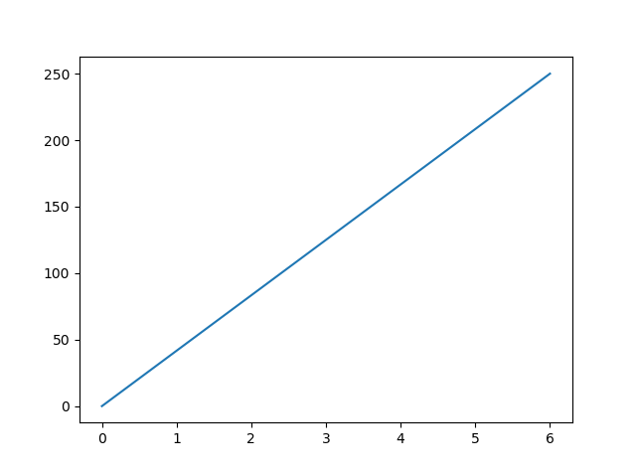

## Plotting Without Line

To plot only the markers, you can use shortcut string notation parameter 'o', which means 'rings'.

### Example

Draw two points in the diagram, one at position (1, 3) and one in position (8, 10):

import matplotlib.pyplot as plt  
import numpy as np  
xpoints = np.array([1, 8])  
ypoints = np.array([3, 10])  
plt.plot(xpoints, ypoints, 'o')  
plt.show()

### Result:

